**CCNA 1 Chapter 5 activity: VLSM to increase security and performance**

In this activity you are required to;

* Create an efficient VLSM design given the requirements.
* Assign appropriate addresses to interfaces and document the addresses.
* Cable a network according to the Topology Diagram.

You will create a small network that requires connecting network devices and configuring host computers for basic network connectivity.

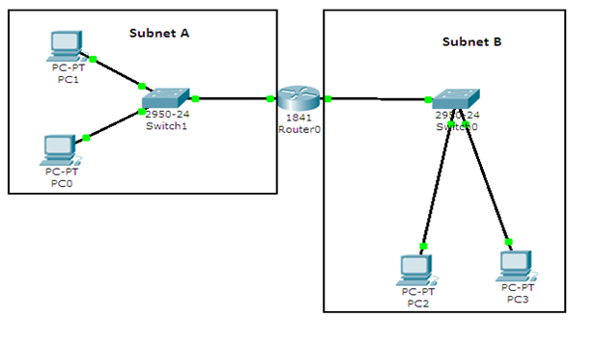

Figure 1: Network Scenario

Task 1: Design the Logical LAN Topology.

Given an IP address and mask of 10.10.1.0 / 24 (address / mask), design a VLSM IP addressing scheme that satisfies the following requirements:

|  |  |
| --- | --- |
| **Subnet** | **Number of Hosts** |
| Subnet A | 8 |
| Subnet B | 56 |

Table 1: Requirements

**The 0th subnet is used. All work must be shown.**

**Subnet B**

|  |  |
| --- | --- |
| **Specification** | **Student**  **Input** |
| Network Address |  |
| Subnet Mask (Decimal) |  |
| CIDR Notation |  |
| First IP Host address |  |
| Last IP Host address |  |
| Number of usable hosts in subnet |  |
| Broadcast address |  |

Table 2: Subnet B

**Subnet A**

|  |  |
| --- | --- |
| **Specification** | **Student**  **Input** |
| Network Address |  |
| Subnet Mask (Decimal) |  |
| CIDR Notation |  |
| First IP Host address |  |
| Last IP Host address |  |
| Number of usable hosts in subnet |  |
| Broadcast address |  |

Table 3: Subnet A

**Host computers will use the FIRST IP address in the subnet. The network router will use the LAST network host address.**

Write down the IP address information for each device:

|  |  |  |  |
| --- | --- | --- | --- |
| **Device** | **IP address** | **Mask** | **Gateway** |
| PC 0 |  |  |  |
| PC 1 |  |  |  |
| Router0-Fa0/0 |  |  | No Gateway |
| PC 2 |  |  |  |
| PC 3 |  |  |  |
| Router0-Fa0/1 |  |  | No Gateway |

Table 4: Interface IP address information

**Task 2: Configure the Logical Topology.**

Open the file called Chapter 5 Topology.pka on the network drive.

Step 1: Configure host computers with correct IP configuration

Step 2: Configure Router0.

Configuration tasks for Router0 include the following:

|  |  |
| --- | --- |
| **Task** | **Specification** |
| Router name | Router0 (Already set) |
| Console Password | Cisco (Already set) |
| Router0 interface Fa0/0 | - set IP address and Mask |
| Router0 interface Fa0/1 | - set IP address and Mask |

Table 5: Router configuration details

**Hint: Use the commands sheet to help configure the router**

Task 3: Verify network connectivity.

Network connectivity can be verified with the ping command.

Can PC 3 be pinged from PC 1?